Implementation and Delivery Plan

The project is estimated to complete within 30 man-days, based on the cooperation of the staff and modules taken.

System Architecture

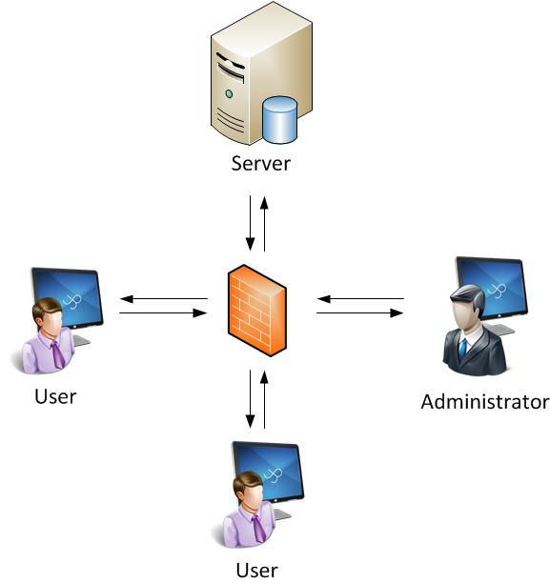

The systems based on a client-server architecture, where the database and files are centralized in the server.

Oasis – E-University
License to Use

License for Oasis – E-University | Price SDG
- Students Management  - Registration Cycle Automation  - Colleges Registry  - Tuition Fees Setup  - Seats Management  - Marks Recording | 9,000
- Financial Management | 7,000
- Human Resources Management | 4,000
Users License | OPEN
Staff Profiles | OPEN
Warranty | 1 Year
Annual Support including:  - Help desk  - Remote Support | 1 Year

If full package taken, choose one of two gifts:
- Online students marks, for publishing students' results online and give access to students through internet.
- Library management system, for managing library's activities (books stores, shelves, search, loans and returns).

Technical Requirements
- Users: good knowledge in using computer (windows), typing, printing...etc
- IT Staff: good knowledge in using Microsoft SQL Server 2008:
  - Setup
  - Configuration
  - Back Up and Recovery
The company is ready to provide training services.

Scope
This project will be developed using .NET (4), MS SQL Server and Crystal Reports.

Input Language
Bilingual (Arabic/English).

Commencement
Within 3 week after signing the contract.

Terms of Payments
- 40 % on contract signature
- 30 % after 1 month
- 30 % after 2 months

Additional Professional Services
Upon successful deployment of the system any future additions/changes will be charged proportionally at standard customary scale (negotiable).
- New requirements
- System customization
- Data Conversion from previous systems
- Additional reports

Validity:
30 days from the date of this quotation.

